SVN Guidelines for Carnot Toolbox

# Version numbering scheme

## Trunk

The Trunk folder contains the latest development version of the current release and should always be ready for release. i.e. should be able to be used without changes.

* bug fixing should be done here
* new functions and Blocks should be added with documentation (at least html help file)
* substantial changes should be done by creating a branch and merging back to trunk after finalization

## Tags

The Tag folder is used for releases and revisions. After the Tag process the created Tag folder should not be changed anymore. Release numbers use following systematic

*R_Major_.Minor_Patch[_Revision]*

Major releases in the repository start with release R_6_01_00. Minor releases and patches start with x_0_0 and are consecutively numbered.

**Major release number**

Major releases indicate breaking changes. All releases under a major release numbers have to be backward compatible in following aspects:

* at least interface to functions and scripts. Block interfaces might be changed
* folder structure
* fundamental design concepts (see “2_Basic_Concepts” help file for details)
* Matlab/Simulink Version for development
* compiler version used for creating mexfiles

**Minor release number**

Minor release numbers indicate changes like new blocks/functions and backward compatible interface changes as mentioned above. The number of changes that justify a new minor release are entirely subjective and have to be discussed in the development group.

Minor releases start with “0” and are consecutively numbered.

**Patch number**

Patch numbers are used for bug fixing and smaller changes. When a new patch is released, is a subject of discussion in the development group.

Patches start with “0” and are consecutively numbered.

**Revision number**

Revisions are used for development versions of new major releases.

For revisions the following system is suggested, which indicates the stage of development.

Major.0.0.a1 . . . alpha Revision 1

Major.0.0.b1 . . . beta Revision 1

Major.0.0.r1 . . . release candidate 1

If not necessary alpha stage can be skipped.

## Branches

Branches are numbered in a similar way as tags but won’t use patch numbers (patching is done in trunk)

*Major.Minor*

Branches are used for development of new features, major and minor versions. During development branches are continuously merged with the latest changes from the trunk. When finished, these branches are merged back into the trunk and a new tag is created (usually as alpha or beta Revision). The revision tag is a matter of discussion in the development team.

# Workflows

3 of the most common workflows in SVN are explained briefly. A more comprehensive explanation can be reviewed here <https://weblogs.asp.net/bsimser/day-to-day-with-subversion>

## Work on Trunk

* update working copy
* make changes
* update working copy with current Rev of Trunk
* commit changes to Trunk
* DONE

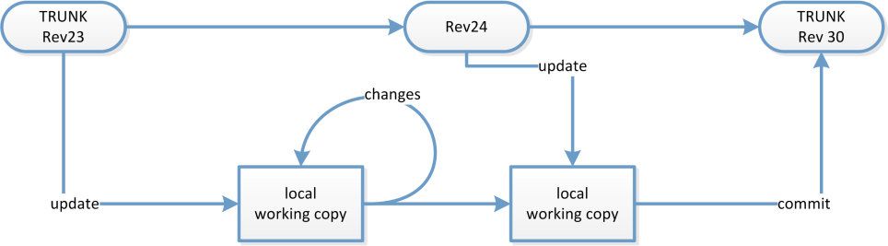

Figure 1: Workflow chart for SVN Trunk

## Creating Tags

* copy Trunk to new tag folder
* DONE

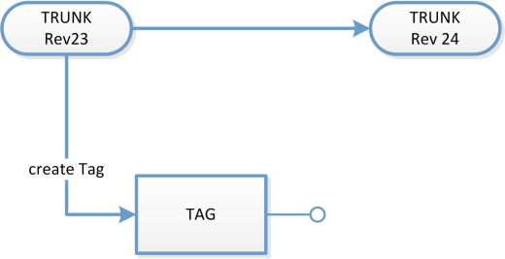

Figure 2: Workflow Chart for creating SVN Tags

## Branches

* update Trunk
* copy Trunk to new Branch folder
* development
* continuously merge Trunk to Branch
* when finished merge Branch back to Trunk
* DONE

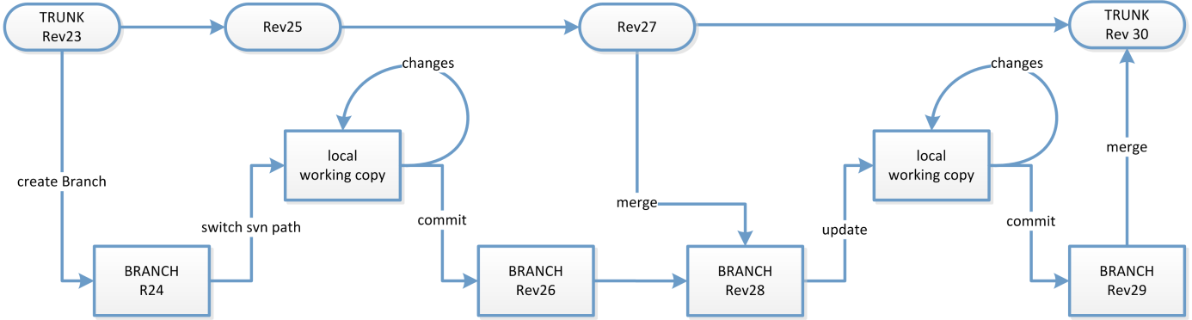

Figure 3: Workflow Chart of SVN Branch